EXERCISE :Introduction to HTML/CSS
1.How are inline and block elements different from each other?
An inline element does not start on a new line and only takes up as much width as necessary.
examples of inline elements are:
- anchor <a> tag
- span <span>
- emphasis <em> tag
- image <img> tag
A block-level element always starts on a new line and takes up the full width of a page, from left to right.
Other examples of the block-level tag are:
- Heading tags <h1> to <h6>
- Div <div>
- List (Ordered, Unordered, Description and List Item) tags <ol>, <ul>,<dl>, <li>
- Pre-formatted text tag <pre>
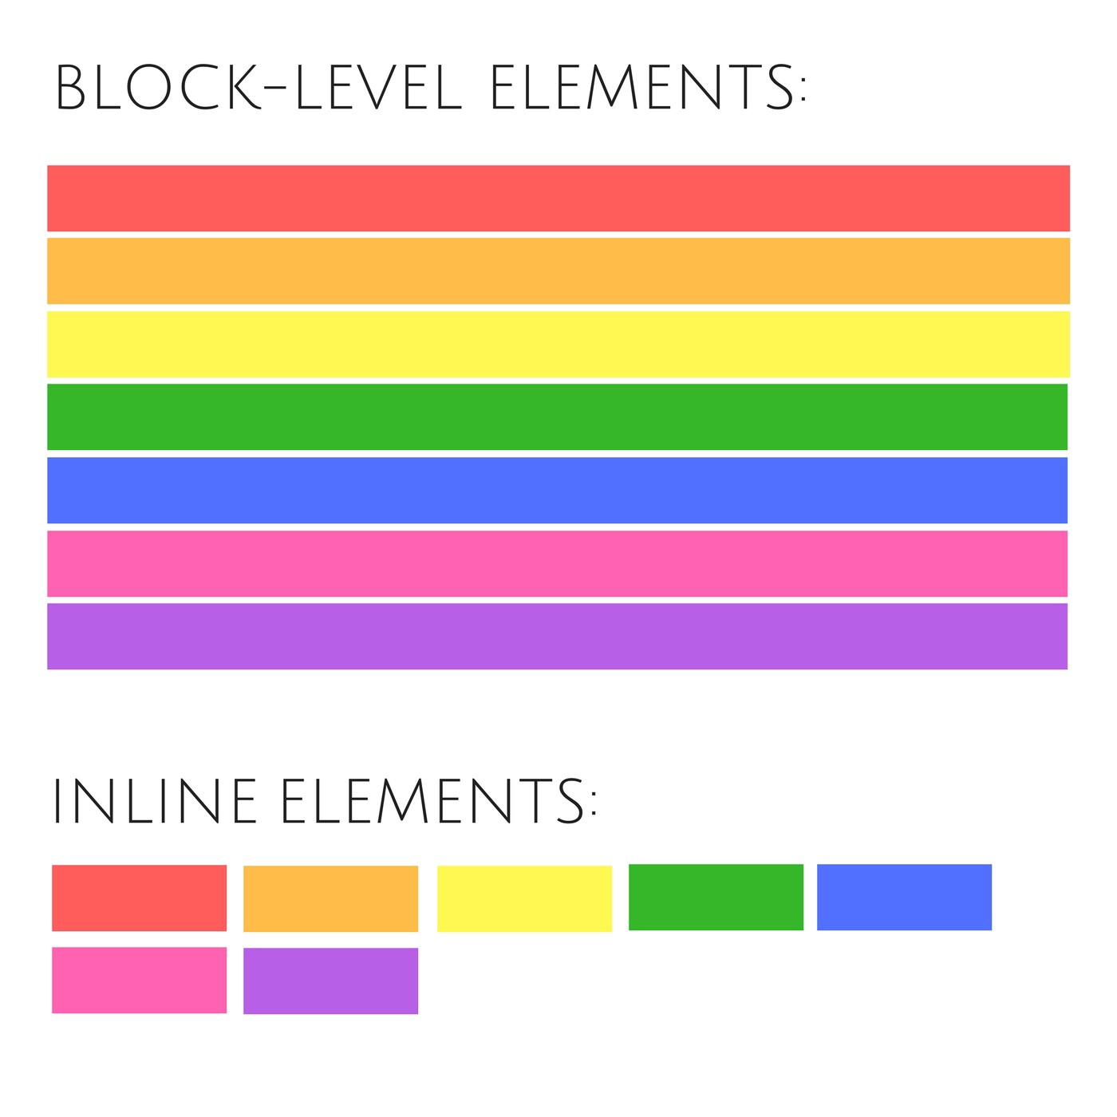
2.Explain the difference between visibility:hidden and display:none
display:none means that the tag in question will not appear on the page at all (although you can still interact with it through the dom). There will be no space allocated for it between the other tags.
visibility:hidden means that unlike display:none, the tag is not visible, but space is allocated for it on the page. The tag is rendered, it just isn't seen on the page.

3. Explain the clear and float properties.
The CSS float property specifies how an element should float.
The float property can have one of the following values:
- left - The element floats to the left of its container
- right- The element floats to the right of its container
- none - The element does not float (will be displayed just where it occurs in the text). This is default
- inherit - The element inherits the float value of its parent
The CSS clear property specifies what elements can float beside the cleared element and on which side.
The clear property can have one of the following values:
- none - Allows floating elements on both sides. This is default
- left - No floating elements allowed on the left side
- right- No floating elements allowed on the right side
- both - No floating elements allowed on either the left or the right side
- inherit - The element inherits the clear value of its parent
The most common way to use the clear property is after you have used a float property on an element.

4. explain difference between absolute, relative,fixed and static.
The position property specifies the type of positioning method used for an element.
There are five different position values:
- static
- relative
- fixed
- absolute
- sticky
HTML elements are positioned static by default.
An element with position: static; is not positioned in any special way; it is always positioned according to the normal flow of the page.
An element with position: relative; is positioned relative to its normal position.
Setting the top, right, bottom, and left properties of a relatively-positioned element will cause it to be adjusted away from its normal position. Other content will not be adjusted to fit into any gap left by the element.
An element with position: fixed; is positioned relative to the viewport, which means it always stays in the same place even if the page is scrolled.
An element with position: absolute; is positioned relative to the nearest positioned ancestor (instead of positioned relative to the viewport, like fixed).
However; if an absolute positioned element has no positioned ancestors, it uses the document body, and moves along with page scrolling.

5. Write the HTML code to create a table in which there are 4 columns( ID , Employee Name, Designation, Department) and at least 6 rows. Also do some styling to it.
-----------------------------attached with the name table.html----------------
6. Why do we use meta tags?
- Metadata is data (information) about data.
- The <meta> tag provides metadata about the HTML document.
- Metadata will not be displayed on the page, but will be machine parsable.
- The metadata can be used by browsers (how to display content or reload page), search engines (keywords), or other web services.
- It helps to improve the SEO( Search Engine Optimization) of a web page by using certain keywords related to the web page.

7. Explain box model.
The imagne is the screenshot of the inspect element’s box model.
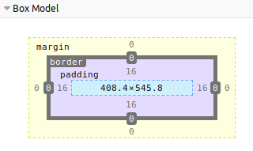
Content - The content of the box, where text and images appear
Padding - Clears an area around the content. The padding is transparent
Border - A border that goes around the padding and content
Margin - Clears an area outside the border. The margin is transparent

8. What are the different types of CSS Selectors?
Most commonly used selectors are :
 | .class | .intro | Selects all elements with class="intro"
 | #id | #firstname | Selects the element with id="firstname"
 | * | * | Selects all elements
 | element | p | Selects all <p> elements
 | element,element | div, p | Selects all <div> elements and all <p> elements
 | element element | div p | Selects all <p> elements inside <div> elements
 | element>element | div > p | Selects all <p> elements where the parent is a <div> element
And many more selectors..

9. Define Doctype.
The <!DOCTYPE> declaration must be the very first thing in your HTML document, before the <html> tag.
The <!DOCTYPE> declaration is not an HTML tag; it is an instruction to the web browser about what version of HTML the page is written in.
<!DOCTYPE html> - for html5

10. Explain 5 HTML5 semantic tags.
Examples of non-semantic elements: <div> and <span> - Tells nothing about its content.
Examples of semantic elements: <form>, <table>, and <article> - Clearly defines its content.
HTML5 offers new semantic elements to define different parts of a web page:
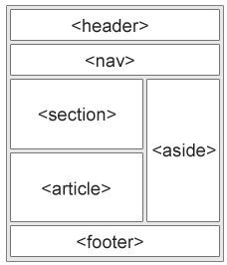
- The <article> element specifies independent, self-contained content.
An article should make sense on its own, and it should be possible to read it independently from the rest of the web site.
- The <header> element specifies a header for a document or section.
The <header> element should be used as a container for introductory content.
- The <footer> element specifies a footer for a document or section.
A <footer> element should contain information about its containing element.
A footer typically contains the author of the document, copyright information, links to terms of use, contact information, etc.
- The <nav> element defines a set of navigation links.
- The <aside> element defines some content aside from the content it is placed in (like a sidebar).

11. Create HTML for web-page.jpg (check resources, highest weightage for answers)
-----------------------------attached with the name webpage.html---------------------------------
12. Create HTML for form.png (check resources, highest weightage for answers)
-----------------------------attached with the name form.html----------------------------------------

